**EXPERIMENT NO:3**

**OBESERVE WORKING PRINCIPLE OF FOUR STROKE PETROL ENGINE**

**Introduction:**

A four stroke engine is an internal combustion engine in which the piston complete four separate stroke while turning the crankshaft.

**Diagram of four stroke petrol engine:**

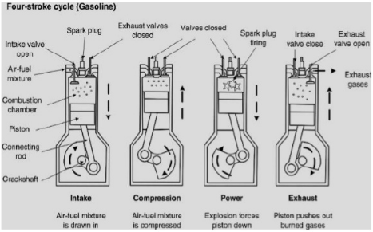

Fig no 3.1: Diagram of four stroke petrol engine

**Process:**

Four stroke engine performs following process.

* Intake
* Compression
* Power
* Exhaust

**Intake:**

Air and petrol mixture enter through intake valve when crank shaft move downward and creates a vacuum and piston move downward as shown in fig 3.1 and crankshaft develop pressure .The exhaust valve closed during intake.

**Compression:**

Air and fuel mixture is compressed and develop pressure and temperature. Piston move from bottom to top as shown in fig 3.1. During compression both intake and exhaust valve are closed.

**Power:**

In third cylinder both valve closed and sparking starts. Explosion forces move the piston downward as shown in fig 3.1.

**Exhaust:**

In this cylinder intake stroke closed and exhaust valve open and exhaust removed. Piston pushed out burned gases. During this process intake valve is closed.

**What is the cam:**

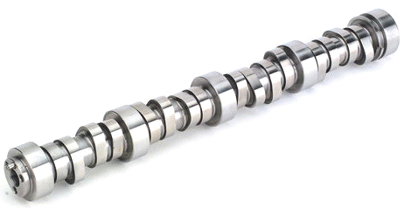

A **camshaft** is a rod which rotates and slides against a piece of machinery in order to turn rotational motion into linear motion. This change of motion is accomplished by the camshaft moving further and closer from the axis of rotation as the camshaft is pushed by the machinery. These moving pieces of the shaft are the [cams](https://energyeducation.ca/encyclopedia/Cam). The linear distance moved is called the 'throw.

**PV diagram**:

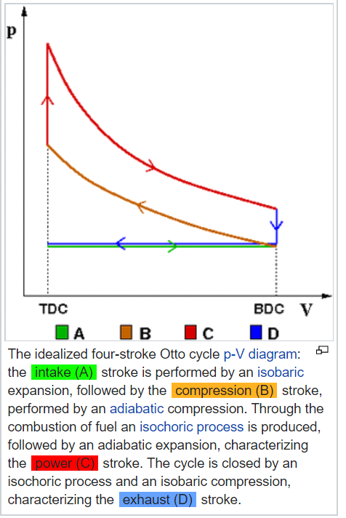

**TS diagram:**

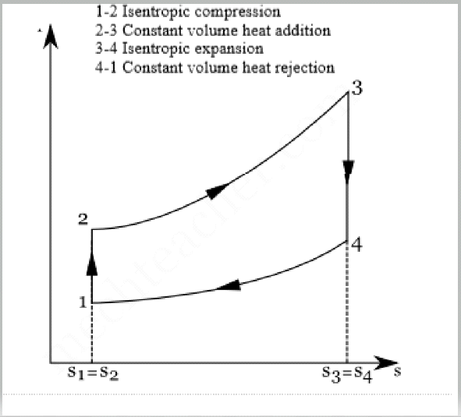

**Application of two and four stroke petrol engine:**

Two-stroke engines are generally less expensive to build as compared to four-stroke engines, and they are lighter and can produce a higher power-to-weight ratio. For these reasons, two-stroke engines are ideal in applications such as chainsaws, weed trimmers, outboard motors, off-road motorcycles and racing applications.

**Difference between two stroke and four stroke engine:**

